DA505 FINAL - FALL 2021

Name:

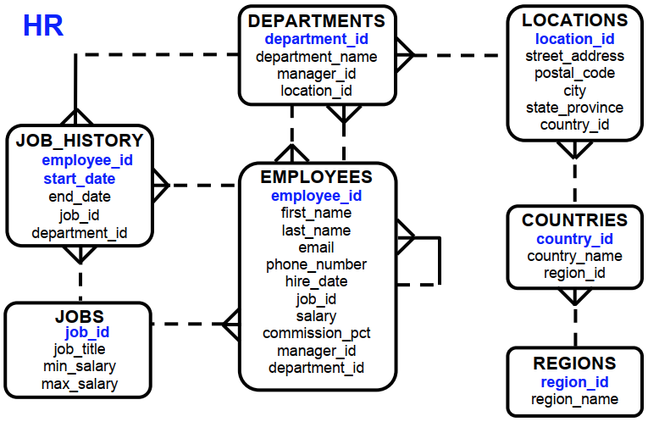

Q1. (15 Pts)

The HR department needs a query to display the jobs (job_id) that are found in the Administration and Executive departments. Also display the number of employees for these jobs. List highest number of employees first.

select j.job_id, count(*)
from hr.jobs j
inner join hr.employees e on (e.job_id=j.job_id)
inner join hr.departments d on (d.department_id=e.department_id)
where
d.department_name in ('Administration','Executive')
group by
j.job_id
order by 2 desc;

Q2. (15 Pts)

Write a query to display the job, the salary for that job based on the department id, and the total salary for that job, for departments 20, 50, 80 and 90.
HINT: Use Case/Decode with group function
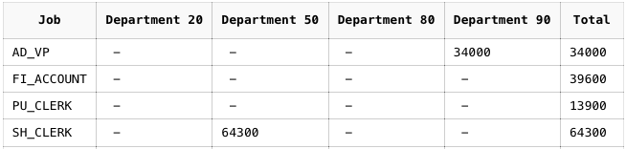
...

Q3. (15 Pts)

Write a query to display the employee’s first name, last name, department name, country name and region name who works in ‘Americas’ and not working in the Shipping department.

select e.first_name, e.last_name, d.department_name, c.country_name, r.region_name
from
hr.employees e
inner join hr.departments d on (d.department_id=e.department_id)
inner join hr.locations l on (d.location_id=l.location_id)
inner join hr.countries c on (l.country_id=c.country_id)
inner join hr.regions r on (c.region_id=r.region_id)
where
r.region_name = 'Americas'
and d.department_name <> 'Shipping'

Q4. (15 Pts)

Find all employees who were hired in the first half ot the month (before the 16th of the month)
Hint: Use only Employees table

select e.first_name, e.last_name, e.hire_date
from
hr.employees e
where
extract(day from hire_date)<16

Q5. (15 Pts)

Examine the following sql query. What is this query trying to find?

SELECT last_name, TO_CHAR(hire_date, 'DAY') day
FROM employees
WHERE TO_CHAR(hire_date, 'DAY') IN (SELECT TO_CHAR(hire_date, 'DAY')
FROM employees
GROUP BY TO_CHAR(hire_date, 'DAY')
HAVING COUNT(*) = (SELECT MAX(COUNT(*))
FROM employees
GROUP BY TO_CHAR(hire_date, 'DAY')));

En çok haftanın hangi günü/günleri işe başlanıyorsa, bu günlerde işe başlayanların soyadının listesi ve başladığı günler.

Q6. (15 Pts)

Write a query to display the departments where no sales representatives work. Include the department number (department_id), department name and location (location_id) in the output.
select distinct d.department_id, d.department_name, l.location_id
from
hr.employees e
inner join hr.departments d on (d.department_id=e.department_id)
inner join hr.locations l on (l.location_id=d.location_id)
where
d.department_id not in (select distinct e2.department_id
from hr.employees e2
where
e2.job_id='SA_REP'
and e2.department_id is not null);

Q7. (15 Pts)

HR department needs a query to display department no (department_id), department name and the number of employees working in each department which has fewer than three employees.

select d.department_id, d.department_name, count(*)
from
hr.employees e
inner join hr.departments d on (d.department_id=e.department_id)
group by
d.department_id, d.department_name
having
count(*)<3;

Q8. (10 Pts)

StudentID
StudentName
CampusAddress
Major
CourseID
CourseTitle
InstructorName
InstructorRoom
Grade

Functional Dependencies:
StudentID StudentName, CampusAddress, Major, Grade
CourseID CourseTitle, InstructorName
InstructorName InstructorRoom

Please normalize the above scheme through 1st, 2nd and 3rd normal forms.
Any answer, other than the solution might be accepted, provided that your design is consistent within itself.

Your answer must to be in following format;

1NF: (2pts)

RELATION_NAME(A,B,C)
RELATION_NAME(D,E,F)

Why 1NF? Which attributes did you choose for PK in each relation?

Adres bilgisi multivalued bi attribute olup bunlar ayırırsak bir relation elde etmiş oluruz, bu da bizi 1NFe getirmiş olur. (Student ve instructor için ad ve soyadın ayrı tutulmayacağını varsaydım, sadece adres için atomize hale getirme işlemi yapılacaktır)

StudentID(PK,FK)
StudentName
CampusAddress_Bilgi1
CampusAddress_Bilgi2
CampusAddress_Bilgi3
Major
CourseID(PK,FK)
CourseTitle
InstructorName
InstructorRoom
Grade

2NF: (2pts)

RELATION_NAME(A,B,C)
RELATION_NAME(D,E,F)

Why 2NF? Which attributes did you choose for PK in each relation?

Partial dependencyleri(pd) kaldırarak 2NF’i elde edeceğiz.
Sadece Student’a ait olan pd’ler: StudentName, CampusAddress, Major, Grade
Sadece CourseID’ye ait olan pd’ler: CourseTitle, InstructorName

TABLO1:StudentAndCourse
StudentID(PK,FK)
CourseID(PK,FK)

TABLO2:Student
StudentID(PK)
StudentName,
CampusAddress_Bilgi1
CampusAddress_Bilgi2
CampusAddress_Bilgi3
Major
Grade

TABLO3:Course
CourseID(PK)
CourseTitle
InstructorName
InstructorRoom

3NF: (6pts)

RELATION_NAME(A,B,C)
RELATION_NAME(D,E,F)

Why 3NF? Which attributes did you choose for PK in each relation?

Tablo1 ve Tablo2 transtive dependency içermediği için zaten 3NF durumundalar.
Tablo3’teki InstructorRoom InstructorName üzerinden transitive olup bunun ayırılmasıyla 3NF elde edilir.

TABLO3:Course
CourseID(PK)
CourseTitle
InstructorName

TABLO3:Course
InstructorName(PK)
InstructorRoom

